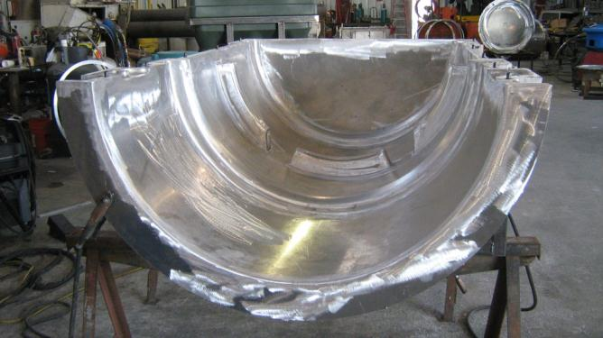
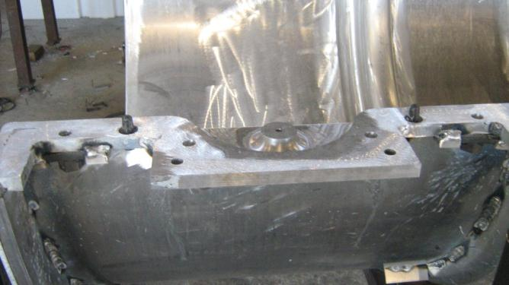
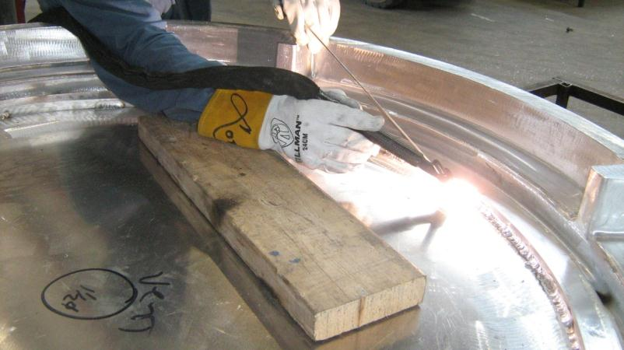
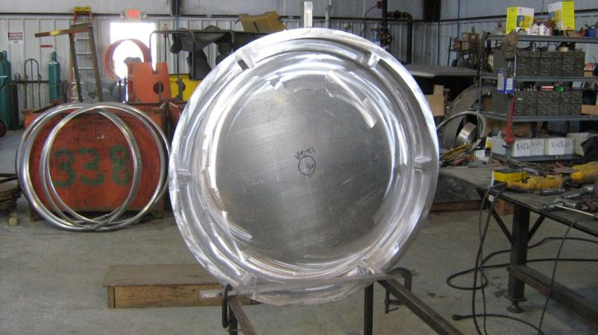
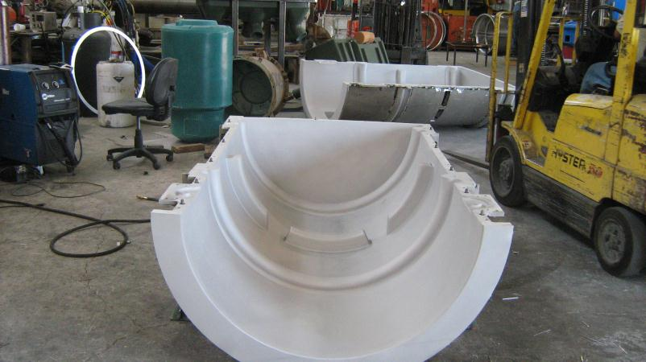
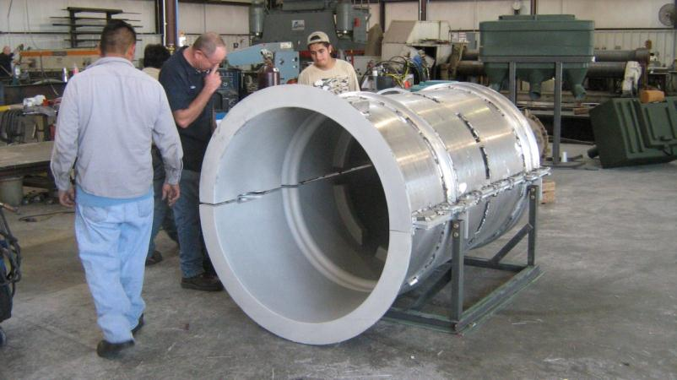
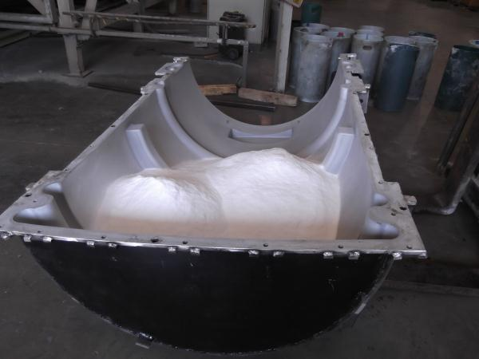
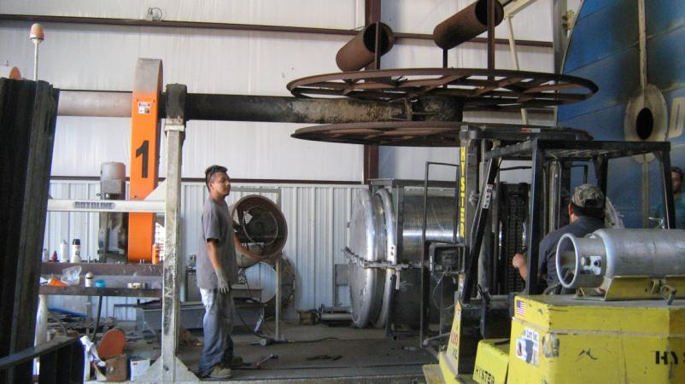
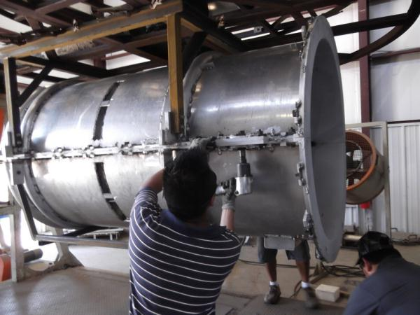
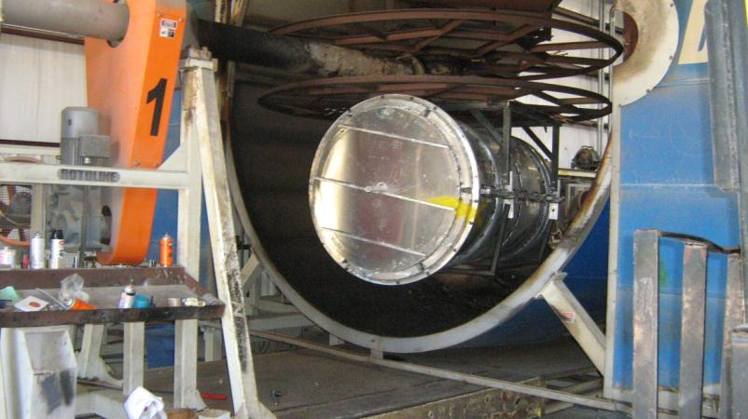
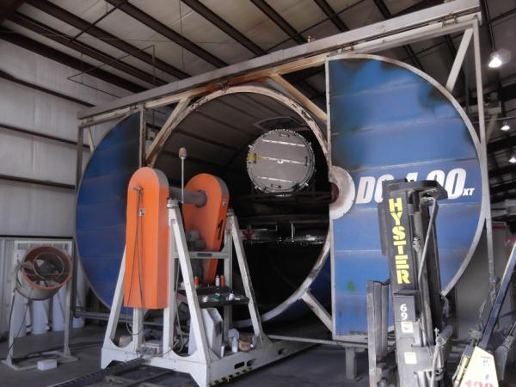
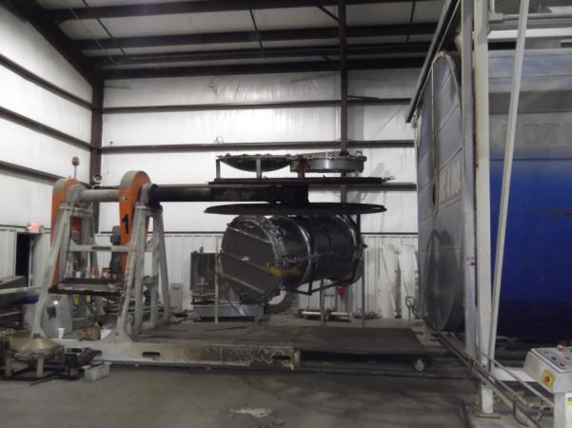
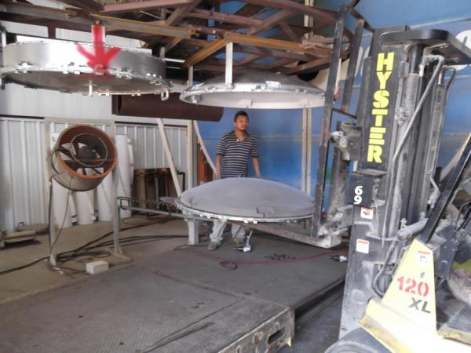
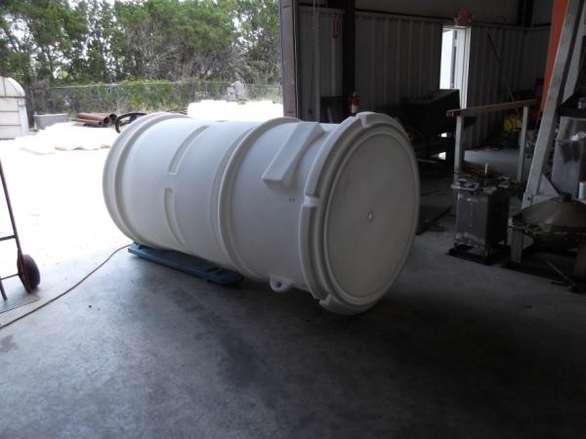
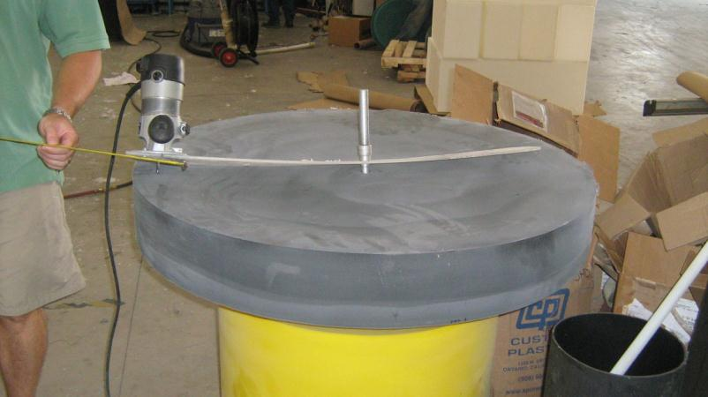
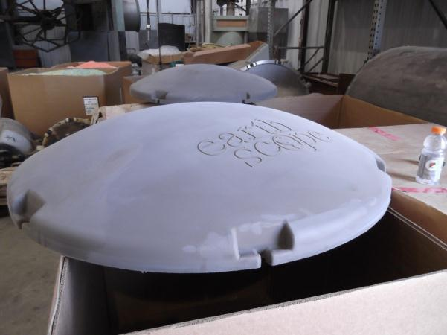
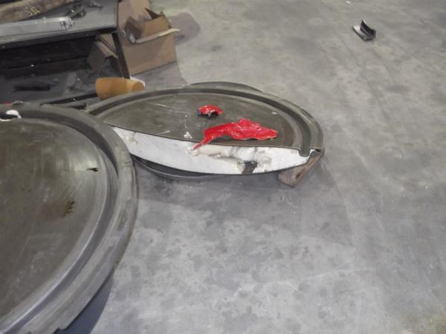
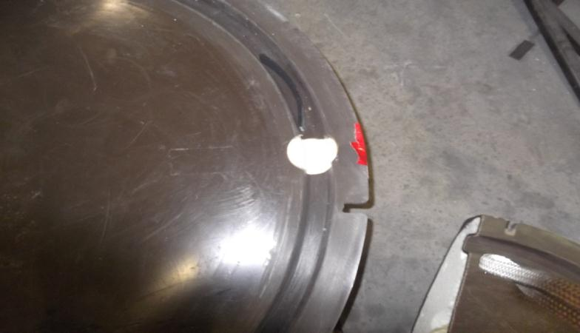
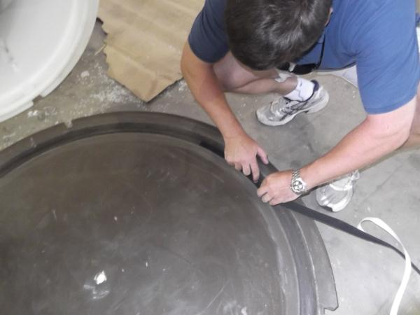
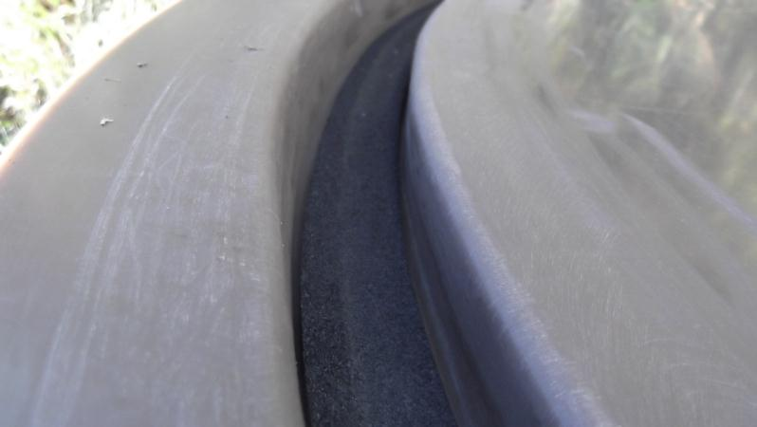
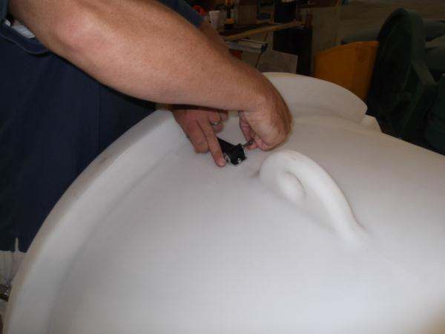
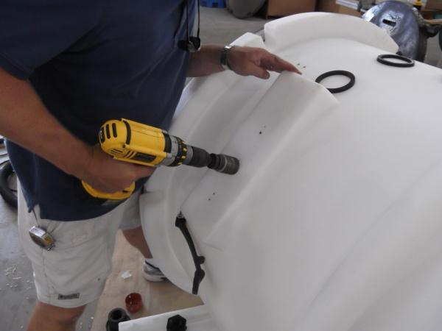
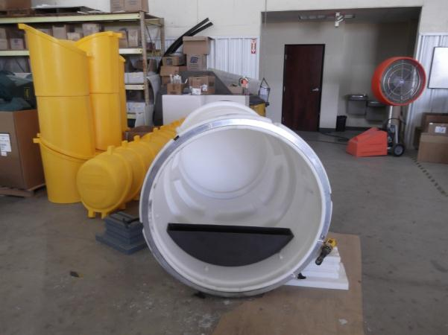
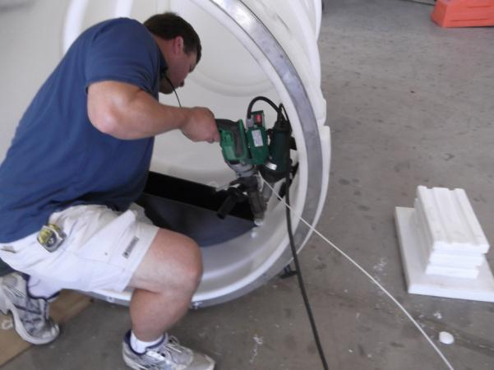
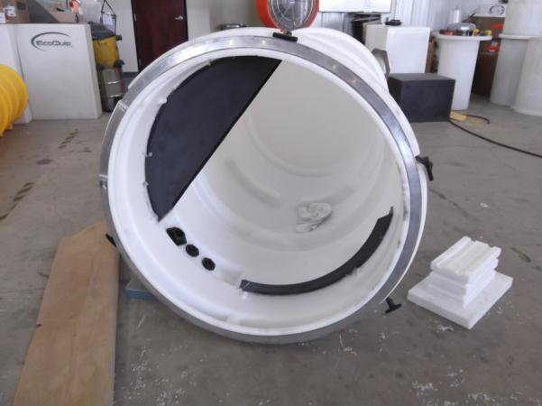
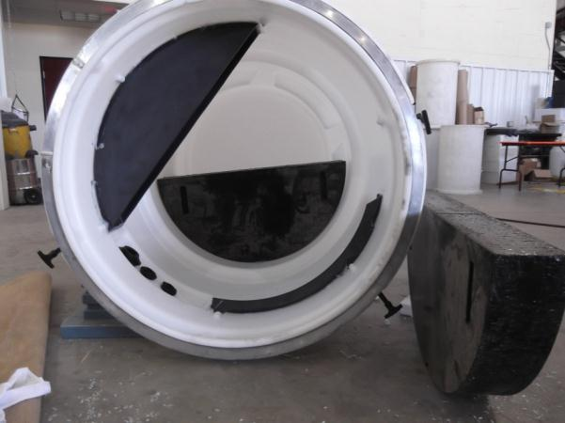
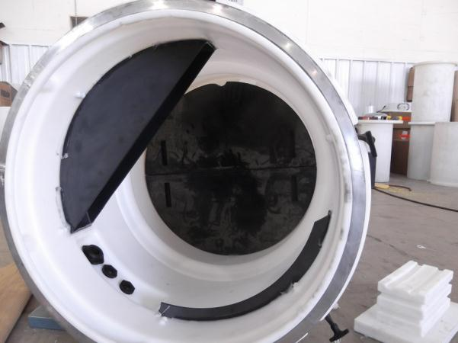
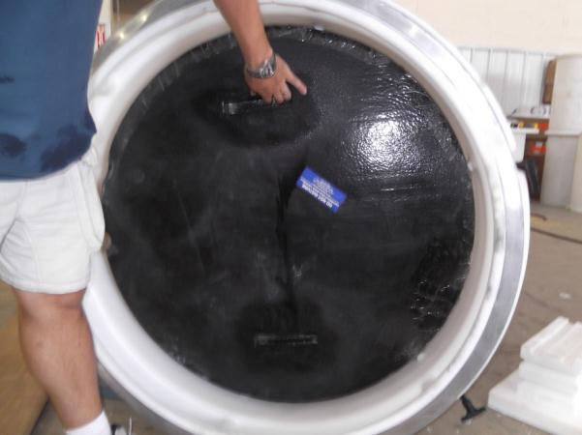
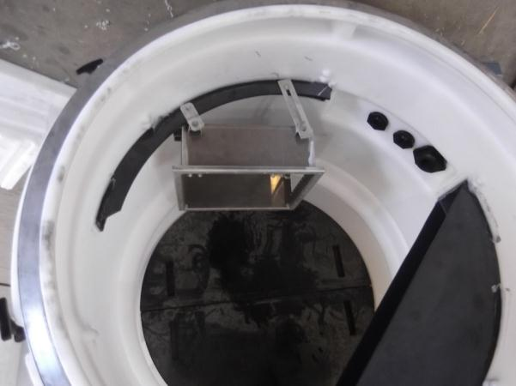
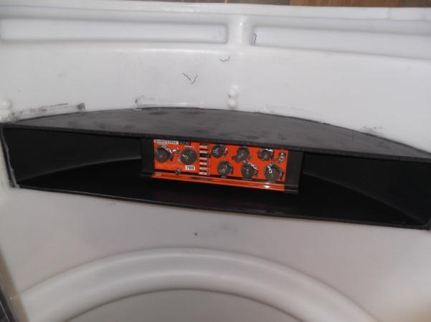
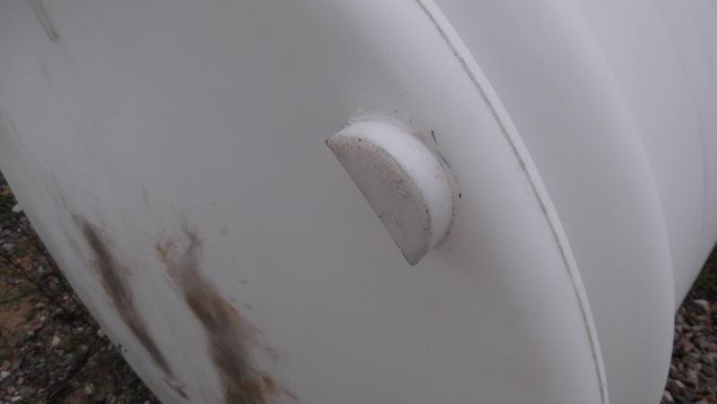
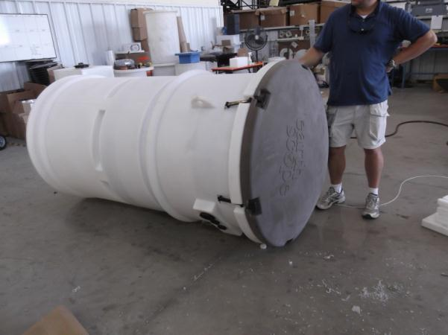
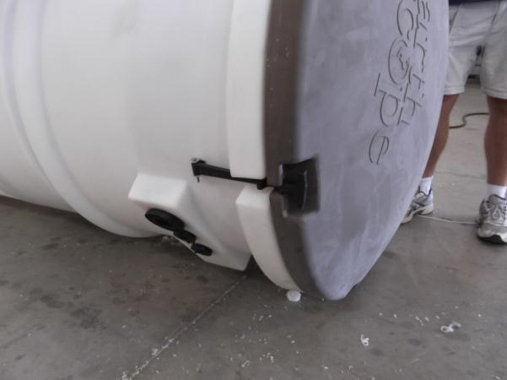
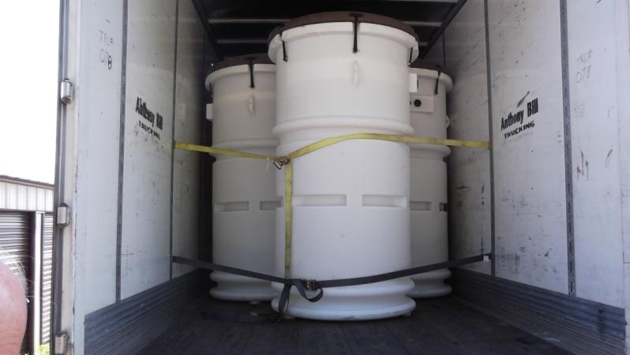
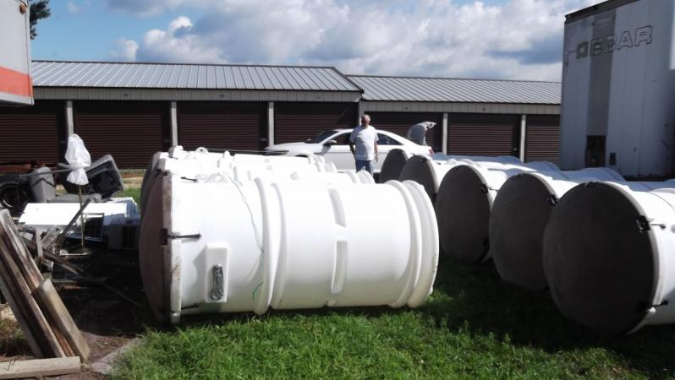
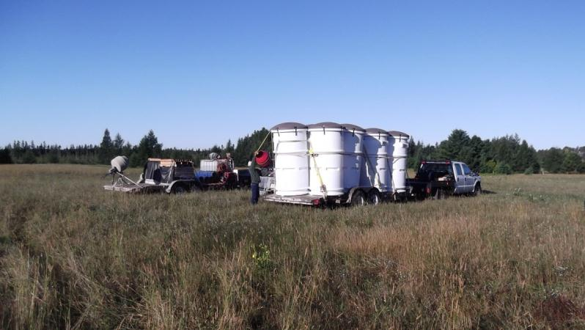
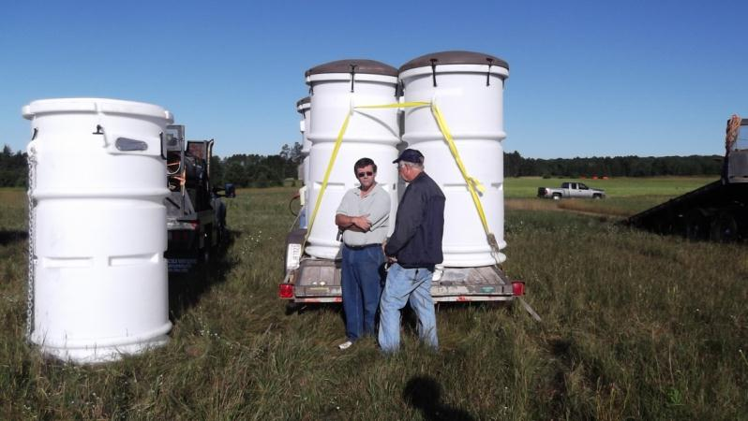
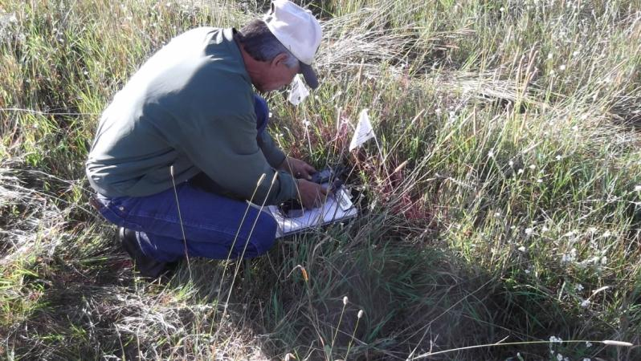
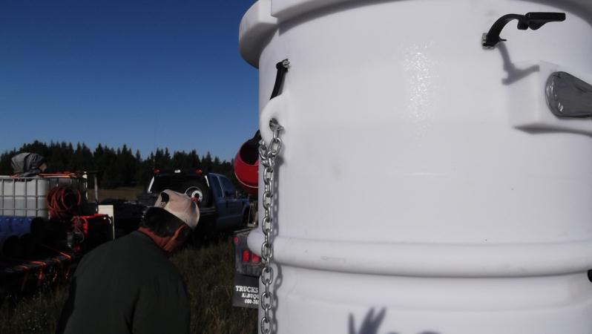
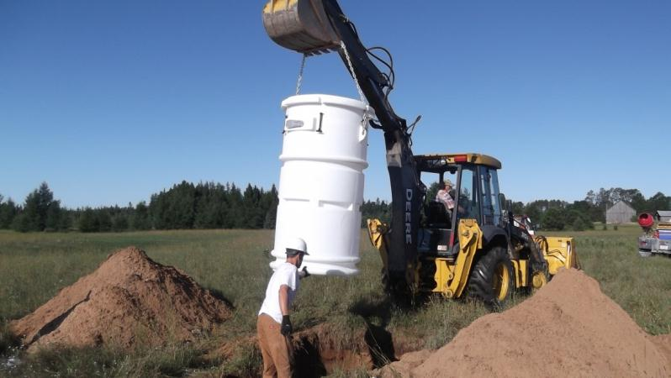
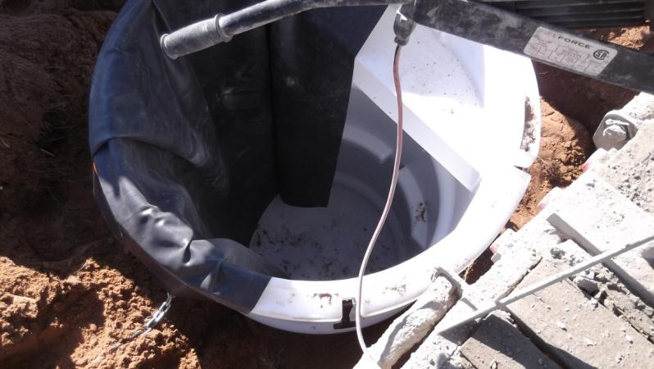
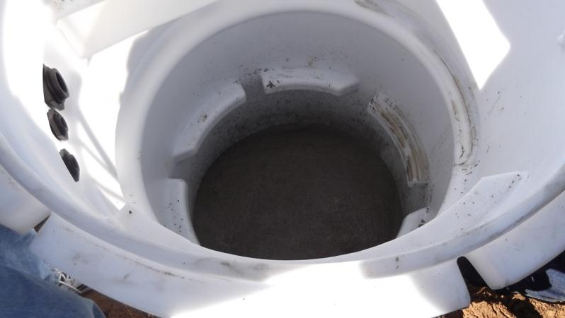
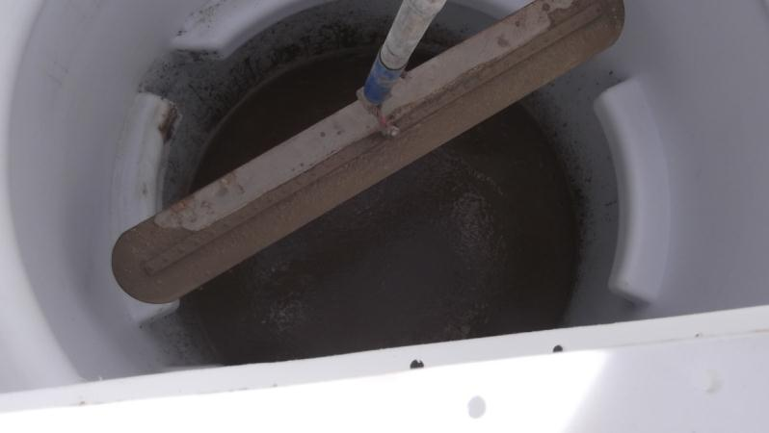
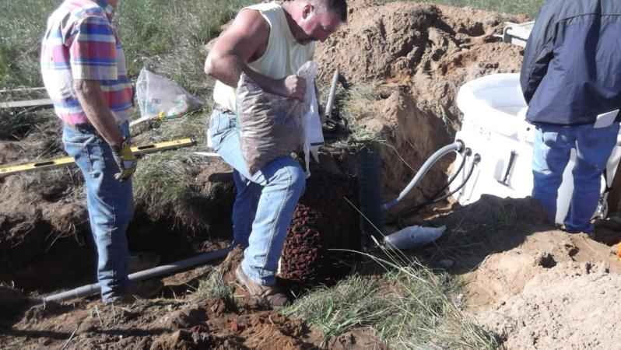
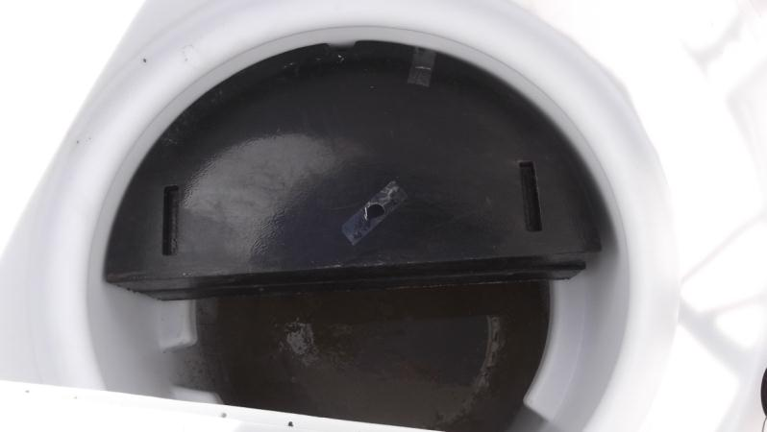
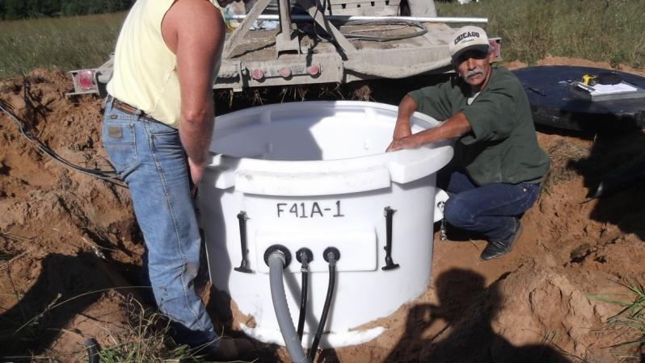
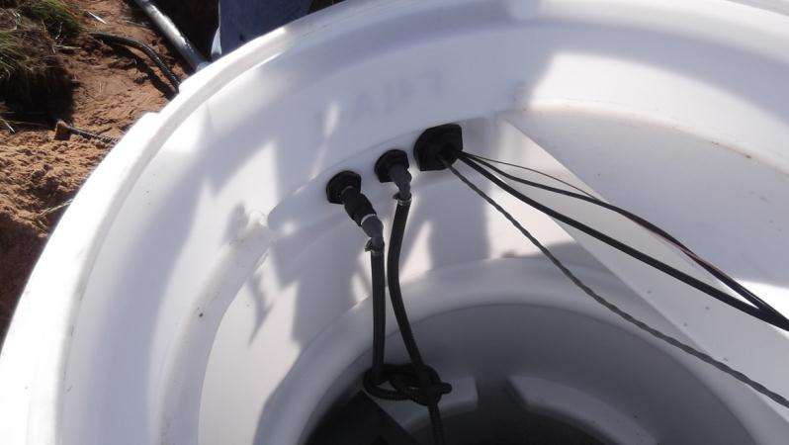
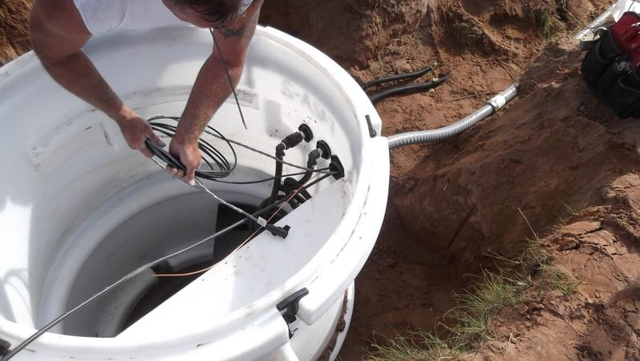
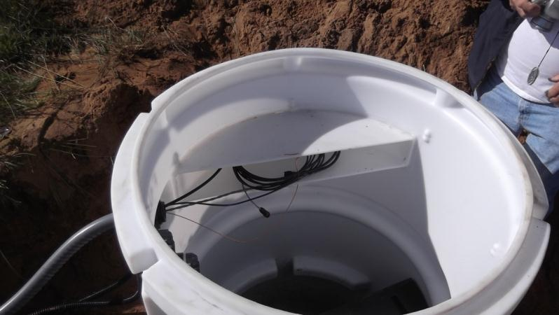
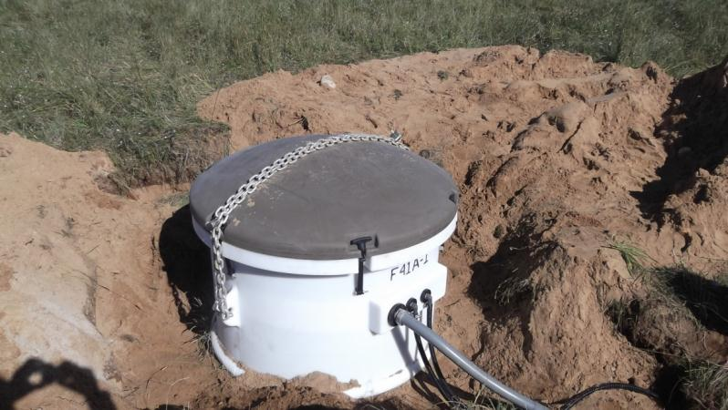
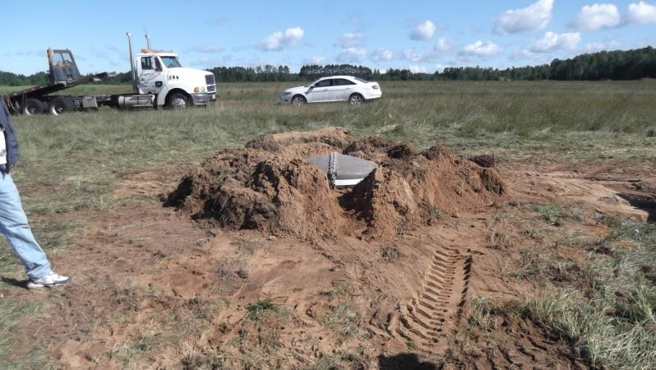
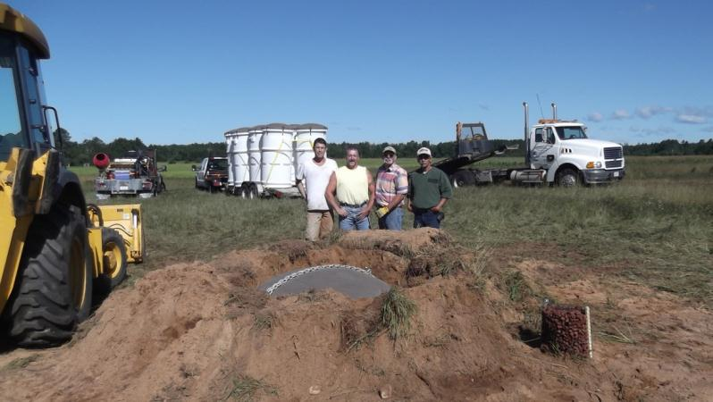
Vault Design B Update
The molds for the new vault were designed and built at Freeman Engineered Products in Burnet, Texas. The molding process is called rotomolding. The plastic is high density polyethylene (HDPE) and can be molded in various colors. Our preferred colors are natural (white with no pigment) for the vault and chocolate for the lid.
The mold is formed from rolled aluminum sheet and tubing. Then the pieces are welded together to form the various features of the design. The mold pieces are then bolted together, filled with HDPE powder, and placed into an oven.
Vault mold being prepared.
Lifting eye.
Top of vault details.
Top of vault.
After molds are welded and ground to shape they are then sandblasted.
The mold pieces are then bolted together and attached to a framework. The frame allows the mold to be easily attached to and removed from the oven rotating arm.
The correct amount of powdered HDPE is placed into the mold. The mold is bolted together and prepared for mounting onto the rotating arm.
The molds are then attached to the rotating arm and inserted into the oven for the heating cycle.

When the oven cycle is complete the oven door opens and the rotating arm backs out of the oven for the cool down cycle.
Water mist is blown onto the mold during the cool down cycle.
After the cool down cycle the molded parts are removed from the molds and allowed to cool and shrink to their final size.
All of the molded parts require some post mold processing. Here the VIE mounting lip is being cut from its parent part. The Q330 shelf is made from the same parent part. One parent part makes 8 VIE mounting lips or 3 Q330 shelves. These parts are then welded to the ID of the vault on either side of the bulkhead feed through connectors.
The EarthScope logo is molded into the lid.
The lid is filled with 2 lb/cf rigid foam. Several trial runs were made to ensure the foam filled all of the lid.
Destructive testing was done to inspect various parts of the lid to ensure proper foam filling.

Closed cell foam gasket being installed into the lid gasket groove.
Gasket shows good fit.
Rubber latches are being installed in six places around the vault with stainless steel hardware.

1 ½” and ¾” bulkhead connectors are then installed in the feed through panel.
Prior to welding the shelf and VIE mounting lip into the vault an aluminum fixture is placed over the top lip of the vault to ensure the vault is round.
The shelf and VIE mounting lip are then welded into place.

The foam pieces were then test fit into the vault.
VIE and Q330 were then test fit into place.
The vaults then had 3 feet welded to the bottom to facilitate shipping and handling.
Final assembly was made.
Vaults were then loaded onto the delivery truck and shipped to Arena and Crandon WI.

Vaults stored in Arena WI.

First new vault in the field at F41A on August 10, 2011.
Don Lippert talking with the landowner, John Stauner about the new vault.
Anthony Gonzales making sure we have the vault in the right place.

Chains attached to lifting eyes.

First new vault being placed in the ground.
Pond liner used as concrete splatter shield.
Concrete floor.
Floor being finished.
Cable, Infrasound, and pump feed through.

6” foam being installed.
Another view of feed through connections.
Vie inside the vault with cables, check valve, and hoses run.
Cables lying on shelf.
Chains locked over lid prior to final backfill.

Channel cut to allow rain water to exit mounded dirt.
The crew, Daniel, Ronald, Reggie, and Anthony.

